**Assignment 1**

1. **Create the following Tables with their respective columns, data types and size.**

|  |  |  |  |
| --- | --- | --- | --- |
| **Table Name** | **Columns** | **Datatypes** | **Size** |
| Instructor | ID | number | 5 |
| Name | varchar | 30 |
| Dept_Name | varchar | 20 |
| Salary | number | 6 |

**Query:**

create table Instructor(ID int, Name varchar(30), Dept_name varchar(20), salary int);

**Output:**

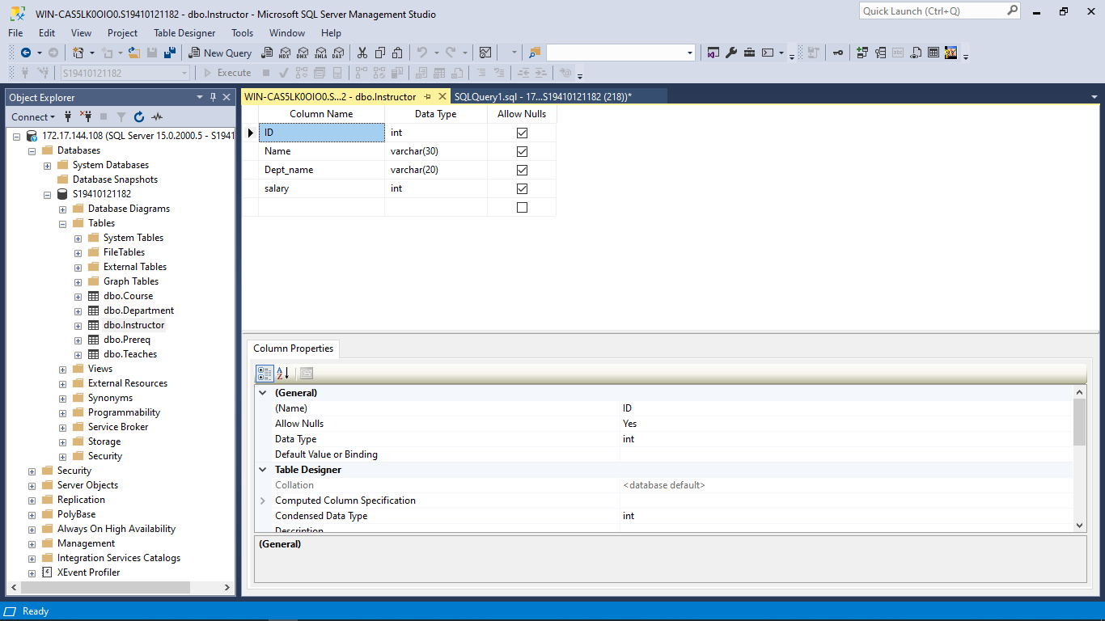

|  |  |  |  |
| --- | --- | --- | --- |
| **Table Name** | **Columns** | **Datatypes** | **Size** |
| Course | Course_id | Varchar2 | 10 |
| Title | Varchar2 | 30 |
| Dept_name | Varchar2 | 20 |
| Credits | Number | 2 |

**Query:**

create table Course(

Course_id varchar(10),

Title varchar(30),

Dept_Name varchar(20) ,

Credits int );

**Output:**

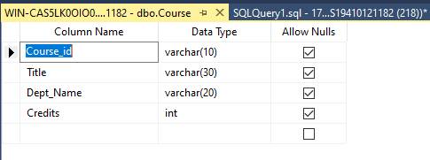

|  |  |  |  |
| --- | --- | --- | --- |
| **Table Name** | **Columns** | **Datatypes** | **Size** |
| Prereq | Course_id | Varchar2 | 10 |
| Prereq_id | Varchar2 | 10 |

**Query:**

create table Prereq( Course_id varchar(10),Prereq_id varchar(10));

**Output:**

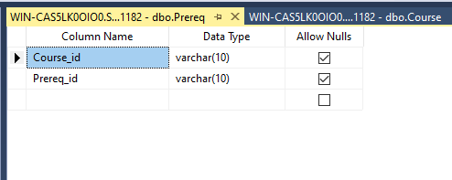

|  |  |  |  |
| --- | --- | --- | --- |
| **Table Name** | **Columns** | **Datatypes** | **Size** |
| Department | Dept_name | Varchar2 | 20 |
| Building | Varchar2 | 20 |
| Budget | Number | 10 |

**Query:**

create table Department( Dept_name varchar(20),Building varchar(20), Budget int);

**Output:**

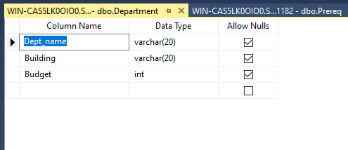

|  |  |  |  |
| --- | --- | --- | --- |
| **Table Name** | **Columns** | **Datatypes** | **Size** |
| Teaches | ID | Number | 5 |
| Course_id | Varchar2 | 10 |
| Sec_id | Number | 2 |
| Semester | Varchar2 | 10 |
| year | Number | 4 |

**Query:**

create table Teaches(

ID int,

course_id varchar(10),

sec_id int,

semester varchar(10),

year int);

**Output:**

